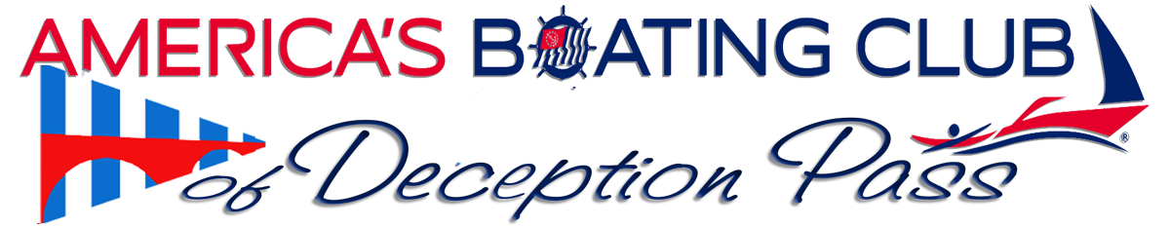
Cruising to Princess Louisa Inlet in BC, has challenges. Meeting those challenges will be part of or next phase of our instruction. Your Club's educators, Bridge Officers, and experienced senior members are compiling a series of instructional points to prepare you for that voyage or any of your planned voyages.
Cruise Planning, Tides and currents. Overview.
Navigation and Charting
Crossing the boarders (US and Canada) (CANPASS is discontinued, now NEXUS Pass recommended)
Canada's boating regulations. VHF Radio, Fishing, Pump outs,
Anchoring in Canada, including Stern Tying!
Provisioning your boat
Meal Prep on your boat.
_______________________________________________________________
Our Winter focus series, Lets cruise to Princess Louisa Inlet in British Columbia. Target Date is June 2024.
To get the juices flowing, the following videos will give a taste of the cruise and the destination.
https://www.youtube.com/watch?v=Q7ZTBAZyKWk *Great Drone pix!
https://www.youtube.com/watch?v=Yje6C1bhbBY In the winter
https://www.youtube.com/watch?v=nUN2TWmIuN4
What to expect
- Preliminary Chart your trip. Can be changed as you are aware of challenges / On line prep via the Navionics.com App or similar / Best idea to make sure you have backup paper charts with you
  - Review the chart and Identify obstacles.
  - Terrain, depth, Military operations space in BC. How to get permission to cross or Go Around.
  - Limit your distance and time in the open deep water during rough water conditions.
  - Develop a clear picture of all the space between departure and destination.
  - Tides and Currents
  - Know the performance of your boat MPG or GPH is based on calm water.
  - Calculate fuel
  - Plan for a problem
  - Safe harborage and Safe Anchorage. PRE LOCATE on your chart.
  - Plan for your best Tides and Currents FREE MILEAGE IF YOU PLAN CORRECTLY.
  - Give yourself extra time! An extra day at anchorage or fighting rough weather in an open ocean situation.. NO BRAINER Don’t rush.
  - During this course of training we will cover the essentials, then it is up to you to PRACTICE and become proficient.
  - Pre Planning
  - Research your departure, cruise, arrival at ports, fuel stops, food provisions, Preparation of your boat, and for you.
  - Check Lists. Make the and Use them.
  - Familiarize yourself with you boats systems
  - House water, drinking water, refrigeration, heat, propane, black water
  - Radio use in BC, Different radio frequencies used in BC, Radio Station License is required, Special MMSI # requirements, HOW TO MEET THE REQUIREMENTS
  - Anchoring
  - Stern Tying Quite common in BC
  - Navigating Deception Pass
  - Navigating the San Juan Islands and the Gulf Islands in BC
  - Crossing the border to BC (CANPASS HAS BEEN DISCONTINUED)
  - https://www.cbsa-asfc.gc.ca/prog/canpass/menu-eng.html
  - BC PROVISIONING… What's allowed and what's not allowed. NO GUNS, Restricted food and equipment items.
  - Keep trash and CARDBOARD (and bananas) OFF the Boat!
  - Fuel in BC
  - Pump Out in BC
  - Fresh water.
  - How to provision your boat, store provisions
  - How to meal prep on a boat.
  - Showering on board
  - Dish washing
  - Returning to the US
  - Clearing Customs in the US
Plan your fuel requirements for best prices.

There will be break out sessions to discuss
On the water training,
spare parts and tools to bring with

MARK YOUR CALLENDER The 3rd Tuesday of each month at 5:30 (Series starts October 17, 2023). Pot luck dinner and training that ensures you will be a safer and better informed boater. Be sure to RSVP early and invite a friend!
Hope to see you there
Jerry Liggett, Squadron Commander, Americas Boating Club of Deception Pass.
jliggett4@hotmail.com

