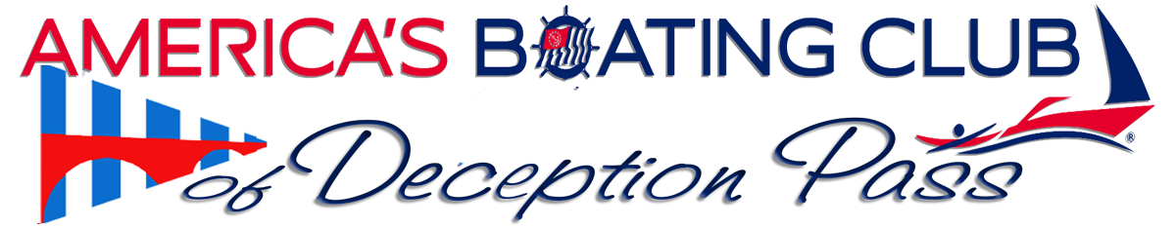
Visit us at http://www.deceptionpasssailandpowersquadron.com/
Monthly Meeting April 16, 2024
Jerry Liggett (Squadron Commander)
Chip White (Squadron Education Officer)
The Navionics App, how to use it.
1. in the last couple of years there have been a few modifications to the Navionics Apps and subscriptions. Mainly, Navionics was bought by Garmin. Not necessarily a bad thing as Garmin is a premiere GPS Charting Co.
2. Cost went up for the App Subscription from 25 to 49.00. and if you buy the chart chips for your Lowrance or Garmin plotters, you are buying from Garmin. Interestingly, I have never seen a "sale" on Navionics, but recently Garmin "Navionics" offered 50 to 100 off your chip with a full subscription for 1 year (constant updates). You own the chip and contents, they just don't update after the year.
3. Lets talk about the App
If you dont have the app on your phone or tablet then cut and paste the link below to get it. There is a FREE TRIAL available for you to try out and subscription if you want to keep it. Subscriptions are for one year and allows you to download charts and use them off line on your phone or tablet. All Apple or All Android products. You can used the same subscriiption on all of your "like" devices.
https://www.navionics.com/usa/apps/navionics-boating
- Chart Viewer can be used free on your computer
- https://webapp.navionics.com/?lang=en#boating@4&key=%7BcijHxcv_V
- This would primarily be used to plan your trips with a larger chart. Functions are similar to App
- Video Beginners guide: This is the manual for new users.
https://www.navionics.com/usa/lp/boating-app/beginners-guide
- MAPS
- When you first download the app, you get a basemap. To see all map details, you will need to download chart data. Find out how to download, update and delete maps in this video.

- LAYERS AND OVERLAYS
- The app provides chart layers and overlays to serve the various needs of boaters and anglers. Watch this video to learn about some of them and how to access them.
- PLANNING TOOLS
- With the app, charts and features are always with you. You can easily and comfortably plan ahead by searching by Lat/Long, saving markers and measuring distances on the map. Watch the video.

- WEATHER
- Before setting out for a boating trip, you need to know what weather to expect. The app provides forecasts and other weather-related info. Watch the video.

- ROUTE
- Creating and following a route is certainly one of the most popular features of the app Learn about the automatic and manual options in this video.

- CONNECTIONS
- Keep track of friends and fellow boaters with sharing of profile, live location, tracks, routes and markers. Learn more.
- https://www.youtube.com/watch?v=4iRWLtzeM78

NAVIONICS SPONSORED BOATING APP VIDEO LIBRARY:
https://www.navionics.com/usa/blog/category/video/boating-app-academy
Port Moody Power and Sail Squadron traininig (An excellent in depth review of the app, approx 90 Min.)
https://www.youtube.com/watch?v=iQplgEkU-nc

